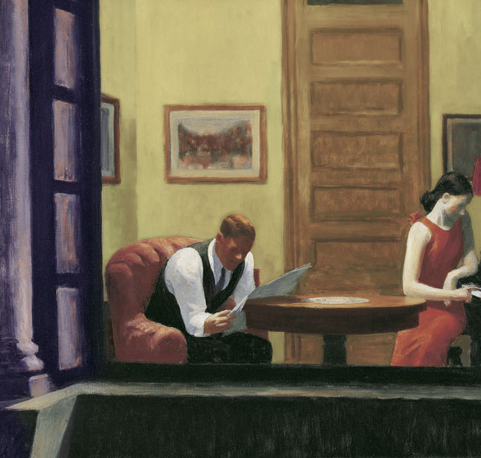
Annual Meeting of the Academy of Philosophy and Letters
June 15-17, 2012
Baltimore, MD
The Doubletree by Hilton

Globalization and The Fragmenting of America:

The Problem of disconnectedness

2012 Annual Meeting

of the

Academy of Philosophy and Letters

June 15-17, 2012

The conference will be held at The Doubletree by Hilton, located at the Baltimore-Washington Airport, in Linthicum Maryland, 890 Elkridge Landing Rd., Linthicum Heights, Maryland, 21090. The hotel provides free limousine service from and to the airport terminal. The hotel can be reached directly by telephone at 410-859-8400. You can reserve a room at the discounted rate of $99 at HYPERLINK "http://doubletree.hilton.com/en/dt/groups/personalized/B/BWIBADT-APL-20120615/index.jhtml?WT.mc_id=POG" http://doubletree.hilton.com/en/dt/groups/personalized/B/BWIBADT-APL-20120615/index.jhtml?WT.mc_id=POG
Our room block will expire on May 15 and is limited, so make the reservation sooner rather than later.

For non-members, attendance is by invitation only. Any member of APL can sponsor non-members as guests. The members of the APL Board of Directors are listed below. Students may attend the conference at a greatly reduced rate (see registration page below). A limited number of registration fee waivers are available.

For more information, contact Jeffrey Polet, Secretary of APL, polet@hope.edu, 616-395-7547, or any member of the Board of Directors

APL Board of Directors
President: Claes Ryn, The Catholic University of America, cryn@erols.com
Vice President: David Jordan, University of Virginia, DJordan643@aol.com
Treasurer: Michael Federici, Mercyhurst College, mfederici@mercyhurst.edu
William Byrne, St. Johns University, byrnew@stjohns.edu
Richard Gamble, Hillsdale College, rgamble@hillsdale.edu
Lowell Gustafson, Villanova University, lowell.gustafson@villanova.edu
Brian Mitchell, mitchellmailbox@aol.com

Globalization and the Fragmenting of America: The Problem of Disconnectedness

Annual Meeting of the
Academy of Philosophy and Letters
June 15-17, 2012

This year’s panels will incorporate a round table format. The panelists will offer 10 minute introductions, which will be followed by discussion among them and members of the audience.

Friday

5:00-6:00 PM. Registration

6:00-7:00 PM Reception/Cash bar

7:00-9:00 PM. Dinner

Welcome
Speaker: Russell R. Reno, Creighton University, Editor, First Things, “Irreverence and
Piety in the Intellectual Life: Sources of Disintegration and Unity” (title
tentative)

9:00-11:00 PM. Hospitality Suite hosted by The American Conservative

Saturday

8:00-8:30 AM. Late registration

8:30-10:30 AM. PANEL/ROUND TABLE 1. Roots of Disconnectedness
“Cooperating Strategies for Dismantling Tradition”

Chair: William F. Byrne, St. Johns University
Comments on Stephen Greenblatt, “historicist”:
Jeffrey Polet, Hope College
Robert V. Young, North Carolina State University
Comments on Allan Bloom, anti-historicist, on the 25th anniversary of The Closing of the American Mind:
Ryan Holston, Virginia Military Institute
Claes G. Ryn, The Catholic University of America

10:30-10:45 AM. Break/Refreshments

10:45-12:45 AM. PANEL/ROUND TABLE 2. The Acids of Oligarchy

Chair: Stephen Jordan, U.S. Chamber of Commerce
Doug Bandow, Cato Institute, Forbes Magazine
Lowell Gustafson, Villanova University
David Jordan, University of Virginia
Brian Mitchell, Academy of Philosophy and Letters

12:45-1:00 PM. Break

1:00-2:30 PM. Luncheon

Speaker: Mike Lofgren, author of the forthcoming Penguin/Viking book, The Party is Over: How Republicans Went Crazy, Democrats Became Useless, and the Middle Class Got Shafted.

2:30-3:30 PM. Break

3:30-5:30. PANEL/ROUND TABLE 3: The Disintegration of Society

Chair: Richard Gamble, Hillsdale College
Winston Elliott, III, The Imaginative Conservative
Mark Kalthoff, Hillsdale College
Steven Klugewicz, National Constitution Center
Mark Mitchell, Patrick Henry College

5:30-6:30 PM. Break

6:30-7:30 PM. Reception/Cash bar

7:30-9:00 PM. Dinner

Speaker: Rod Dreher, The American Conservative, “Stability: The Case for Going Home”

9:00-11:00 PM. Hospitality Suite hosted by The American Conservative

Sunday

9:00-10:00 AM. Breakfast meeting of the membership (members only)

10:00 AM-noon. PANEL/ROUND TABLE 4. The Problem of Disconnectedness

Chair: Michael Federici, Mercyhurst College

Brad Birzer, Hillsdale College
Mike Church, The Mike Church Show
Robert Delfino, St. John’s University
Nathan Harter, Christopher Newport College
Daniel McCarthy, The American Conservative

12:30-2:00 PM. APL Board of Directors Meeting

Conference dress code: coat and tie

REGISTRATION FORM

Participants may register using the following form, or by using APL’s paypal site and sending the fee to mfederici@mercyhurst.edu

The amounts below refer to pre-registration. Registrations postmarked later than May 30 will be assessed a surcharge of $25.

2012 Late Dues after May 15 (members only) | Members | Non-Members | Students | Please check
2012 Late Dues after May 15 (members only) | $60.00
Friday Dinner and Program | 40.00 | 50.00
Saturday Program, Lunch, and Dinner | 120.00 | 140.00
Sunday Breakfast and Program | 25.00
Sunday Program Only |  | 25.00
Conference Program Only (no meals) |  |  | 75.00
Total included:

Name:

Address:

Telephone:

Email:

APL Sponsor (if applicable):

Mail to the APL treasurer: Michael P. Federici
Department of Political Science
Mercyhurst College
Erie, PA 16546
(814) 824-2560
mfederici@mercyhurst.edu

